MODULE 2
5-10

Different disciplines:
- Starting point: cognitive psychology (academic discipline of interaction design) → discipline that explores internal mental processes (ex. how people perceive shapes, why they remember or forget things, how they experience emotions).
- Then we’ll move to: cognitive ergonomics (academic discipline of interaction design) → it’s concerned with mental processes like perception, memory, reasoning, motor response that affect interactions among humans and other elements of a system
It studies relationships between our system and how it is affected/it affects other systems.
- Human computer interaction (interdisciplinary field of interaction design)→ it tries to understand how people use and experience interactive technology (computer science, psychology, cognitive science, organisational and …
- Interaction design → ‘umbrella term’ covering all aspects of what is being designed (like user interface design, software design, web design, product design…) . It is composed by different parts like design practices, interdisciplinary fields and academic disciplines, disciplines stated above will be studied more in deep later on
Cognition
What is it?
We can classify it into two different ways:
- Experiential or reflective (Norman) → the first is automatic cognition, when we’re not aware of doing something like riding, while the other is the controlled cognitive process, we reflect when we use it like when we have to write a report
- Fast or slow (Kahneman) → 2+2 is fast, 21 x 29 is slow, we have to think about the process

NB We can divide cognition on the basis of differences among cognitive processes:
- Attention
- Perception
- Memory
- Learning
- Reading, speaking, listening
- Problem solving, planning, reasoning and decision making
Some are conscious while others are unconscious, automatic (from Norman definition)

How can understanding cognition help human-AI interactions and design efficient technology?
- Because we understand capabilities and limitations of individuals in terms of their expected actions
- If we know our strength and limitations we can ‘predict’ and understand errors that can arise while using intelligent systems
- It can provide us theories and useful modelling tools for the design of better intelligent products

Perception
Definition → Psychological process to which we interpret sensory stimulation

NB What we see is different from what we interpret therefore we have to design interfaces that are readily perceivable. Ex: legible text and distinguishable icons (too much white space is not good)

Colours
Implications for design:
- Colours that we distinguish most easily are those that cause a strong signal on one of the three colour-perception channels (red-green, yellow-blue, black and white)
- Colour perception → distinctive colours are better + avoiding strong opponent colour pairs + we should avoid colour pairs that people who are colour-blind cannot distinguish

Gestalt theory (1920 Germany) → It claims that we perceive objects as well-organised patterns rather than separate items

- Proximity: it is the visual tendency to group shapes together if they are close together, the group will be then perceived as a single unit
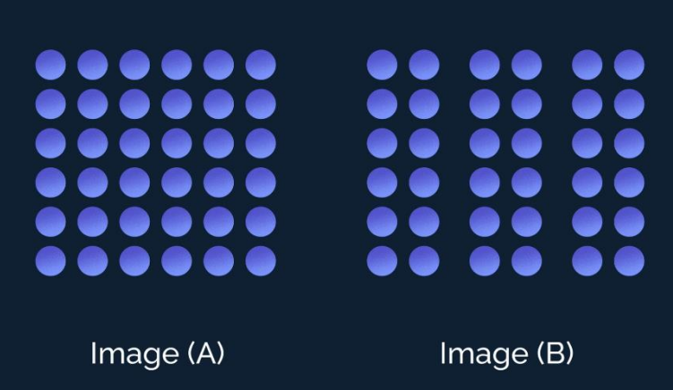
- Similarity: it is the visual tendency to group together similar elements regardless of their proximity (grouped by colour, shape or size)

- Continuity: visual tendency to create continuous figures, it occurs mostly with lines
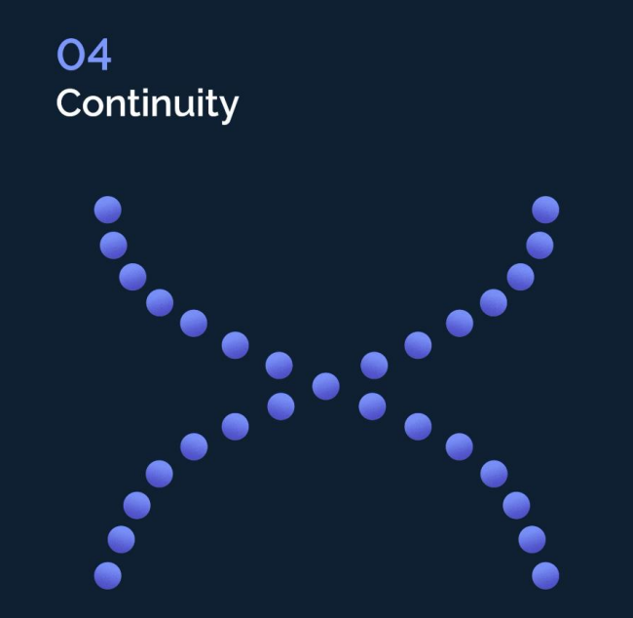
- Closure: tendency to perceive incomplete objects as complete and to close or fill gaps and to perceive asymmetric stimuli as symmetric


Perception and design implications
- Users use icons to distinguish their meaning readily
- Using borders and spaces are effective visual ways of grouping information
- Avoid ambiguity, all users have to be in the position of interpreting things in the same way
- Be consistent (with shapes, colours, fonts….)
- Understand goals (ensure the interface clearly directs users to the right goal)

Perception can be biased by:
- Experience
- Goals since they influence where we look

Attention:
- Spacing
- Multitasking → it can cause people to lose their train of thoughts, make errors and need to start over. This is because it is thought it overloads people’s capacity to focus.

We can make a distinction between heavy and light multitaskers, the heavy ones are more prone to being distracted and they can’t filter irrelevant information.

NB Another study conducted by Lotteridge found out that heavy multitaskers are easily distracted but they are able to achieve the task if the distracting source is relevant to the task, on the other hand, the irrelevant ones to the opposite → conclusion: it is important the kind of info we are given during performing a task.

Attention and design implications:
- It is important to make info which is relevant also for attention
- Avoid cluttering visual interfaces with too much info
- Consider designing different ways to support effective switching and returning to an interface

10-10
Memory
Memory is the ability to retain information over time
- Three stages of memory: encoding – storage – retrieval
- Three memory stores: sensory store – short-term store – long-term store

- Encoding stage: consists of placing a piece of information in memory
- Storage stage: when the information is stored in memory
- Retrieval stage: occurs when the information is recovered from storage

Sensory memory 🡪 Short-term memory 🡪 Long-term memory
- Sensory memory is a very large and transient memory store, it can contain a lot of information, but for a very short amount of time
- Short-term memory keeps information you are conscious of, it is readily accessible but subject to decay (over around 20 sec). Information that is rehearsed or undergoes other forms of processing, can be transferred to long-term memory
- Long-term memory is the unlimited store of the information generally available to us
[George Miller (1956): max number of items that participants can recall in order is almost always between 5 and 9. It has been applied in interaction design when considering how many options to display]
It is not necessarily the case that this number is the optimal design choice to be applied.
In fact, when scanning through a list of bullets, the users don’t have to recall something from memory, they simply search for the one they want. You can have more than nine at the interface (however, sometimes a small number is good, e.g., smart watches). It depends on the task and available screen estate.
Byrne and Bovair (1997) studied cognitive errors with ATMs when people made withdrawals from bank accounts. Post-completion errors (to forget doing something when being asked to perform different actions) occurred when the user completed their task of withdrawing cash but failed to remove their bank card from the ATM.
These errors tend to happen when users have an additional step to perform after their primary task.

Working memory is a term used by psychologists to refer to the system responsible for the temporary storage and processing of information. (e.g. Baddeley model: interactive system which links perceptual information to long-term memory). It helps us with different operations in our everyday life and has a role in many cognitive functions. But it has small capacity when dealing with new information, so it can easily be overloaded. Performance depends on an individual’s WM capacity and on the cognitive load made by the task.
With the ATMs study, it was found that post-completion error only occurred when the load on working memory was high. In these circumstances, the presence of an additional step overloads limited working memory. These results led to the redesign of ATMs, with the results that they now only dispense cash after first returning the card.
Reduce cognitive load by avoiding long and complicated procedures for carrying out tasks.
Long-term memory:
- Recall: the mental process by which we bring to our present consciousness the past stimuli without presenting the physical stimuli
- Recognition: the mental process by which we recognize previously seen stimuli from new ones
See and choose is easier than recall and type. Use pictures where possible to convey function.
Distributed cognition is an approach to cognitive science research that was developed during the 1990s, within the field of embodied cognition. It provides a framework and method to examine the interactions between people and objects by highlighting the complex interdependencies between people and objects. Information is transformed through different media (computers, displays, paper, minds)
[The extended mind (Clark and Chalmers, 1998): artefacts, objects, technology in general could be considered as an extension of our minds. Knowledge and cognition are not confined to the brain – other objects within the environment function as a part of an extended mind. How can we design new kinds of technologies and interfaces that would empower our cognitive abilities while reducing cognitive efforts.]
We could use common strategies to prevent forgetting and to avoid the effort of remembering (e.g. diaries, calendars, notes, reminders…). External representations remind us what we need to do, when etc. and technology can be designed to help us.

12-10
Cognitive frameworks are used to explain and predict user behaviour when interacting with a technology.
- Based on theories of behaviour
- Focus is on mental processes that take place

Mental Models
Craik (1943) described mental models as internal constructions of some aspect of the external world enabling predictions to be made. It involves conscious (controlled) and unconscious (automatic) processes; imagery and analogies are activated.
People use their mental models to:
- Reason about a system
- How to interact with it, how it works
- Figure out what to do when things go wrong
However,
- They are incomplete
- Constantly evolving
- Not accurate representation
Users “see” the system through mental models and rely on mental models during usage. There are various forms of mental models, which can support the users’ interaction.
[NOTE: The designers also have a mental model, but they do not necessarily match the users’ mental model]
The system itself has a specific functioning, called system image. The goal is to reduce the discrepancy between the three aspects (designers’ mental model, users’ mental model and system image)
Principles developed to try to design interfaces to reduce the gap, to help people to build more effective mental models:
- Visibility: the more visible a function is, the more users will notice and use it
  - Make relevant parts visible
  - Make what has to be done obvious

- Feedback:
  - Sending information back to the user about what has been done
  - Includes sound, highlighting, animation and combination of these

- Constraints:
  - Restricting the possible actions that can be performed
  - Helps prevent users from selecting incorrect options
  - Three main types (Norman, 1999):
    - Physical (the object’s size or shape prevents or stops certain actions from occurring)
    - Cultural (localised signals, e.g., writing)
    - Logical (relies on common sense, e.g., gravity)

- Mapping: relationship between controls and their movements and the result in the world

- Consistency: design interfaces to have similar operations and use similar elements for similar tasks
  - e.g., always use ctrl key plus first initial of the command for an operation (ctrl + C, ctrl + S…)
  - Main benefit is consistent interfaces are easier to learn and use
  - Internal consistency refers to designing operations to behave the same within an application – difficult to achieve with complex interfaces
  - External consistency refers to designing operations, interfaces etc., to be the same across applications and devices – very rarely the case, most successful in product families (e.g., MS Office)

- Affordances: functional attributes of an object that allow people to know how to use it
  - E.g., a mouse invites pushing, a door handle invites pulling…
  - Direct perception of functional properties allows to understand, without any particular cognitive elaboration, which objects of our environment are useful to reach a given goal
  - Norman (1988) used the term to discuss the design of everyday objects
  - Since then, it has been popularised in interaction design to discuss how to design interface objects (e.g., scrollbars to afford moving up and down, icons to afford clicking on…)

Gulfs of Execution and Evaluation
The notion of gulfs provided a discourse to explore potential mappings and mismatches between how a system was designed to work and how a person understands how to do a task using it.
- Gulf of evaluation: What’s the system's current state? It is the distance from the user to the physical system.
- Gulf of execution: How do I use the system? It is the distance from the physical system to the user.
An early conceptual framework in HCI. The “gulfs” explain the gaps that exist between the user and the interface. Bridging the gulfs can reduce cognitive effort required to perform tasks. Can reveal whether interface increases or decreases cognitive load and whether it is obvious what to do next (Norman, 1986, Hutchins et al., 1986).
Embodied interaction
Dourish used the term embodied interaction to describe an approach to interaction design that places an emphasis on understanding and incorporating our relationship with the world around us, both physical and social, into the design and use of interactive systems.
“Embodied Interaction is based on the understanding that users create and communicate meaning through their interaction with the system (and with each other, through the system).” - (Dourish, 2001)

Interaction models are based on embodied metaphors:
- Cognitive structures of higher-order thinking that emerge from recurrent patterns of bodily or sensori-motor experience. Such recurrent patterns in bodily experiences are also referred to as image or embodied schemate.
A metaphor allows us to understand abstract concepts in terms of concrete, embodied concepts.

17-10
Emotion and HCI
HCI has traditionally been about designing efficient and effective systems. Now we care more about how to design interactive systems that make people respond in certain ways.
Emotional interaction is concerned with how we feel and react when interacting with technologies.
- Emotional design: designing interactive products to evoke certain kinds of emotional responses in users.
- Emotional AI or affective computing: designing technology to detect and recognise someone’s emotions automatically from sensing aspects of their facial expressions, body movements, gestures and so forth.
What is an emotion?
- Emotions generate affective experiences, such as pleasure or displeasure.
- Emotions stimulate the generation of cognitive explanations to attribute the cause to ourselves or the environment, for example.
- Emotions trigger a series of internal automatic nervous system adjustments, such as increasing heart rate and reducing skin conductance response.
- Emotions trigger behaviours that are often, but not always, expressive (laughing or crying), goal-oriented (approaching or avoiding), and adaptive (eliminating a potential threat)
In essence, an emotion is a full body/mind/behaviour response to a situation.
Mood state 🡪 long-lasting affective states (Picard, 1997)
Emotions are often short-lived and aroused by a specific event, but when an emotion is repeatedly activated, it can give rise to a mood state.
- Russell (2003): emotions are distributed in a two-dimensional circular space, containing: valence (pleasure-dislike) and arousal (deactivation-activation)
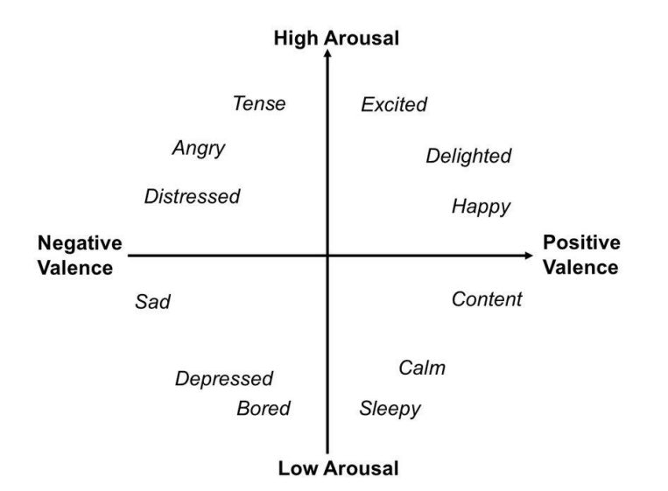
- Ekman (1992) argued that there are six basic emotions (i.e., anger, disgust, fear, happiness, sadness, surprise) and that they could be recognised by facial expressions, in different cultures.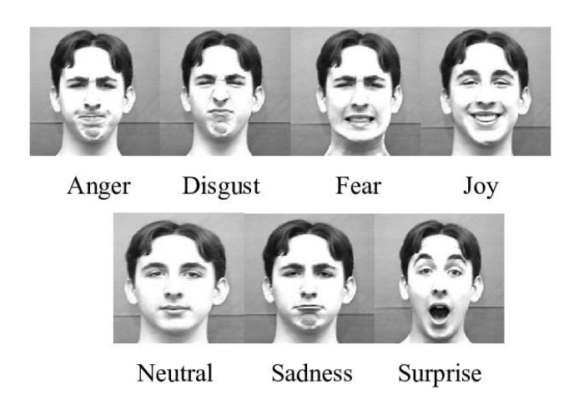

Traditional human factors and cognitive ergonomics researchers have been primarily concerned with the physical and cognitive aspects of human beings to prevent frustration, pain, stress, fatigue, overload, and potential injury in the design, development and use of products and systems.
- Valence: an artefact characteristic that governs the user’s fundamental response interaction process, i.e., liking and attraction vs disliking and avoidance.
  - E.g., Body-face bias: a tendency to see people and things with baby-faced features as more naïve, helpless and honest than those with mature features
  - Gestalt principles: they can make a design coherent and orderly and, therefore, pleasing to look at
- Arousal: it can be defined as a psychological and physiological level of activation and can affect a person’s sensory and attentional alertness. In some areas, including training, learning and gaming, an optimal level of arousal is also important to maintain or to prevent a particular level of arousal as a prerequisite for optimal performance and positive emotions.
  - Studies have shown the existence of an optimal level of performance per single task, namely the inverted U-shaped Yerkes-Dodson law

19-10
[Example of emotional design: emotional icons were used in the 1980s to indicate rebooting or crashed computer]
Emotional Design
Norman (2004) described three levels of cognitive processes that give rise to emotional associations between the human user and the product, namely visceral, behavioural, and reflexive.
- The visceral level focuses on sensory reactions mediated by the physical characteristics of the interactive system (e.g., appearance, touch sensation and sound), which are directly related to valenced reactions to the system (e.g., approach or avoidance). Visual design is widespread in industries like automotive or electronics.
-> Make products look, feel, and sound good
- The visceral level informs the behavioural level, and the user subconsciously evaluates the design according to whether it achieves the goals of effectiveness, efficacy and satisfaction. Behavioural design aims to improve human-product interaction by focusing on usability, performance, and functionality. Good behavioural design begins with understanding users’ needs, generating ideas, testing concepts, receiving feedback, and refining the system.

-> About use, traditional values of usability

- As the interaction between the user and the system accumulates, at the reflexive level the user consciously evaluates the benefits, values, culture, and meaning brought by the system, often forming emotional bonds between the user and the system itself. At this reflexive level, the value of the system can exceed the value at the visceral and behavioural level, satisfying people's actual needs and establishing their image and identity in society.
-> Consider the meaning and personal value of a system
There is a hierarchy of five needs (Maslow’s pyramid of needs) – physiological, safety, social, esteem, and self-actualization; as each need is substantially satisfied, the next need becomes dominant.
- Self-actualization represents the desire to reach one’s full potential and pursue personal growth, creativity, and self-fulfilment. It’s about becoming the best version of oneself.
- Esteem: achievement, success, respect by others
- Social: love, friendship, society
- Safety: physical safety, financial security, safe environment
- Physiological: air, water, food and sleep
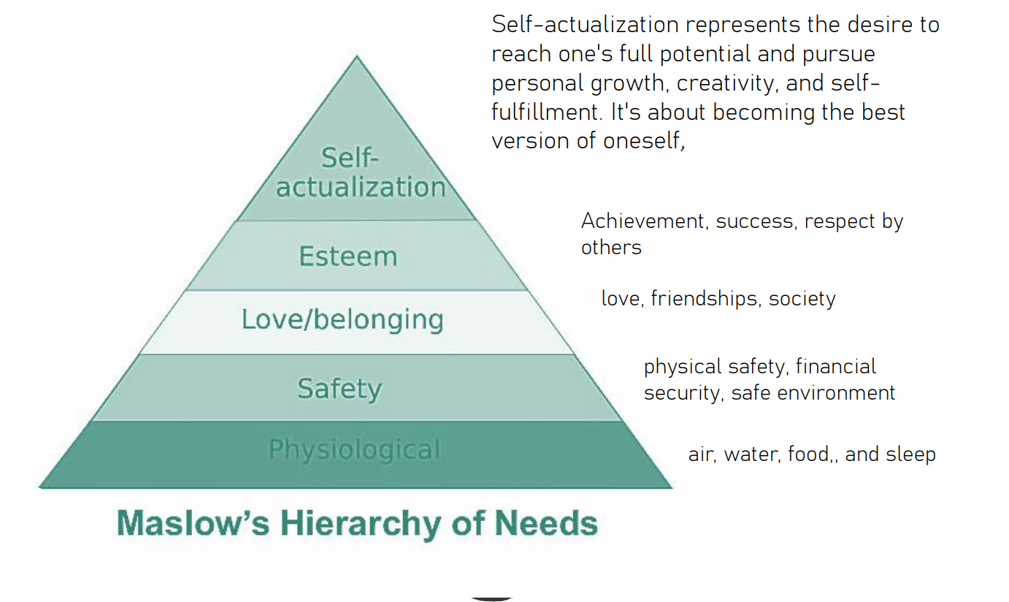

Emotional AI or Affective Computing
Picard (1997) coined the term “affective computing” intending to design and develop systems capable of recognizing, interpreting, responding to, and simulating human emotions.
Affect sensing refers to a system that can recognize emotions by collecting data through sensors and building algorithms to recognize patterns of emotions, based on Ekman’s discrete emotion model or Russell’s dimensional emotion model.
Many researchers have used psychophysiological signals (e.g., GSR, electroencephalogram (EEG), heartbeat), facial and vocal expressions, and/or hormones to recognize emotions.
By recognizing and monitoring users’ emotions, the system can respond to users to improve learning education (Wu, Huang, & Hwang, 2016), communication with autistic children, and also video games.
Some systems used to provide all the information about the user’s physiological state:
- Cameras for facial expressions
- Biosensors to collect psychophysiological signals
- Affective expression in speech (e.g., intonation, pitch, and loudness)
- Body movement and gestures using accelerometers and motion capture systems

Steps of an affective computer model:
Data acquisition 🡪 Data cleaning 🡪 Feature selection 🡪 Algorithm training, validation and testing 🡪 Feedback restitution

Research has focused on detecting the basic emotions from the face. Ekman and Friesen developed the Facial Action Coding System (FACS) to measure facial activity using objective component facial motions or “facial actions” as a method to identify emotion.
They identified a set of action units (AUs) that identify independent motions of the face. Trained human coders decompose an expression into a set of AUs, and this coding technique has become the leading method for objectively classifying facial expressions in the behavioural sciences.
Despite the challenges, some important progress is being made toward the development of fully automated face-based affect detection.

------------------------------------------------------------------------------------------------------------------------

Analysis of paper n°3 (Stress Recognition Using Wearable Sensors and Mobile Phones)
Topic and emotion theory: Identify and summarize the primary topic or psychology theory explored in the article
Experimental paradigm: Describe the experimental setup and methods used in the study
Biosignals collected: Identify and describe the biosignals or data collected during the experiment. Discuss how these biosignals relate to affective computing
Results: summarize the main findings and results presented in the article
Questions Relevant for Affective Computing: identify and list questions that the article raises
AIM: find physiological or behavioural markers for stress

TOPIC & EMOTION THEORY:
The paper’s main topic is the study and the recognition of stress, through the interaction between humans and electronic or “intelligent devices”, such as wearables or smartphones.
We can say that stress is one of the major problems in modern society. Sometimes people are aware of being under stress, for example, when they are occupied with deadlines of homework and projects; however, long-term conditions with high stress can be chronic and people may be less likely to notice whether they are under high stress or may be generally less sensitive to stressors. Stress detection technology could help people better understand and relieve stress by increasing their awareness of
heightened levels of stress that would otherwise go undetected.
The approach used in the paper is a system called affect sensing, that is, a system that can recognize emotions by collecting data through sensors and building algorithms to recognize patterns of emotions.
In the case of stress, we should also think about whether we are really talking just about an emotion. In fact, an emotion is a short-lived response to a certain situation, but, as mentioned before, stress can also become chronic, especially in today’s frenetic and fast-paced world, which often does not allow for the mind (and body) to rest. In this case perhaps we could also consider it as a mood state, which, according to Picard’s theory refers to a long-lasting affective state. In either case, we know that emotions are made of different factors, i.e. they are combination of body/mind/behaviour responses to certain situations, stimuli or states, we can detect emotions by analysing these responses, in particular the ones that can be more easily measured physiologically, like the health data, which is what is done and described in detail in the paper, with different types of data extracted and analysed from participants

----------------------------------------------------------------------------------------------------------------------------------------------

MODULE 1

26-10

human - system interaction → intersection of human-computer interaction and AI

Some people claim AI is part of human-computer interaction but also the opposite is affirmed by other people.
AI and HCI: two fields divided by a common focus

Jonathan Grudin claimed that AI and HCI have a common focus: both explore the nexus of computing and intelligent behaviour.

From a disciplinary point of view the two fields have opposite behaviours, when there were AI winters, HCI was strong.

Success points of AI:
1956→ Dartmouth workshop
Lighthill report→ on this page a committee affirmed that all money used in AI was wasted because nothing was achieved.

Success points of HCI:
Fifth generation

Meeting points:
DARPA’s IPTO→ info processing techniques office pursued an investment strategy in line with the vision of the office’s first director.

Questions:
Human side→ What is a system? What is an AI system?
Interaction side→ how to design and evaluate interaction? What is interaction?

J.C.R Licklider (1960s): “Computers are not only superfast calculating machines, but joyful machines: tools that serve as a new media of expression, inspiration to creativity, gateways to a vast world of online information.”

Jonathan Grudin: “Successful AI applications strengthen the tie to HCI by providing triggers for further research and create a demand for new and better interfaces.”

Scientific method can be used for both scientifical and social studies. In particular, since we consider design as a science, we can use it also for design:

        - Problem identification
        - Literature and benchmark review
        - Objective setting
        - Design & development
        - Artifact evaluation
        - Analysis
        - Hypothesis testing
        - Delivery

We can see prototypes as embodied, material hypotheses. Also prototypes, like hypotheses, have to be tested and iterate (if the prototype does not meet the design, it is improved until it meets the requirements).

Evidence-based design

EBD can be defined as “the process of basing decisions about the [designed system] on credible research to achieve the best possible outcomes” (The Center for Health Design, 2016), or as
“the conscientious, explicit, and judicious use of current best evidence in making decisions about the [design of computational artifacts].
It is different from Eminence-Based Design: the source for a recommendation must be an empirical study, possibly with a comparative intervention-control approach.

Evidence: “any empirical observation about the apparent relationship between events/phenomena.”

EBD advocates a balanced integration of the skills and experience of the design practitioner, the client’s needs, and critically assessed evidence of various types. These include evidence grounded in rigorous scientific methodology as well as a continuum of levels of evidence including personal experience(?).
There is a ladder of the levels of strength of evidence which can be constructed, made of 11 levels (the picture has only 7):
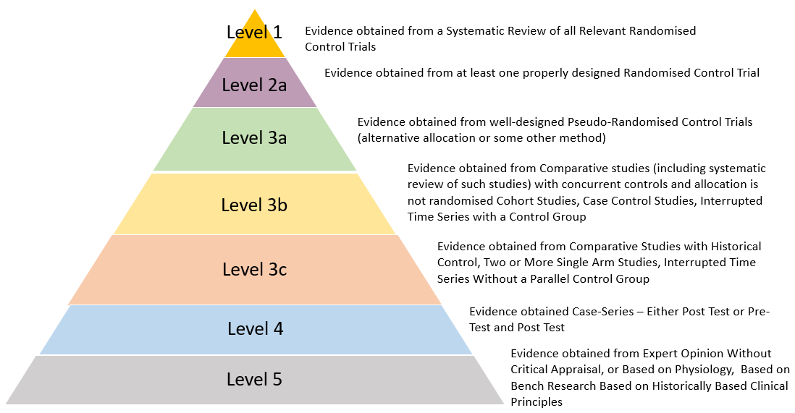

[RCT (Randomized Controlled Trials) are trials in which you have two groups: a controlled group, which uses a first system, and a, intervention group, on which you test another system (usually the actual one you want to test, e.g., a new drug). The randomization factor is the most important part, to have a study which does not suffer from bias]

Designer fallacy: the designers should not think that, once deployed, the solution will stay stable and not need other interventions or fixes based on users’ feedback.
We have to collect evidence about (and thus base our design on:
- Design solutions that are associated with the best effect,
- Design solutions that make the technological intervention adopting them have the greater desired effect on the context of use.
A system (AI) intervention is an intervention (which relies on AI/system/component/technology) to serve its purpose (e.g., help humans on something).
Human-AI/system interaction: the process of how human interact with the (AI) intervention, for this to function as intended.
A system:
- Can be static or dynamic
  - Dynamic 🡪 can be linear or closed-loop
    - Closed-loop 🡪 recirculating or self-regulatory
      - Self-regulatory 🡪 can be first- or second-order
        - Second-order 🡪 can be self-adjusting or learning
A system is the combination of interacting elements organized to achieve one or more stated purposes. (We are interested on designed system/artifacts.)
A socio-technical system is a system that includes a combination of technical and human or natural elements. [NOTE: technical does not necessarily mean just technological]
(ISO 9241) An interactive system is a combination of hardware and/or software and/or services and/or people that users interact with in order to achieve specific goals.
[An artifact is a technological, material interactive system. You should also define the use protocols, i.e., the ways in which the artifact should be used.]
FBS Framework:
- Function: why the system exists. What it is intended to do (teleology) through its behaviour. Also, intended intentional, effectual-effective behaviour (“intended use” or “intended purpose” for fixed purposes systems vs general purpose systems)
- Behaviour: what the system does. How the artifact operates or behaves to achieve its function. We distinguish between expected behaviour, i.e., the behaviour the designers planned, and actual behaviour, the behaviour the system exhibits in the real world when it’s operating, derived from the structure. (Also, distinguish between functional behaviour, which is perceivable, effectual, function-oriented behaviour exhibited at interface level, and inner behaviour, that is the non-perceivable, behind-the-interface behaviour. Both can be either actual or expected)
- Structure: how the system does it. It represents the tangible or intangible components of the artifacts and their relationships, that is the configuration that allows the artifact to exhibit its behaviour, usually by being immersed in a material energetic flow or field.
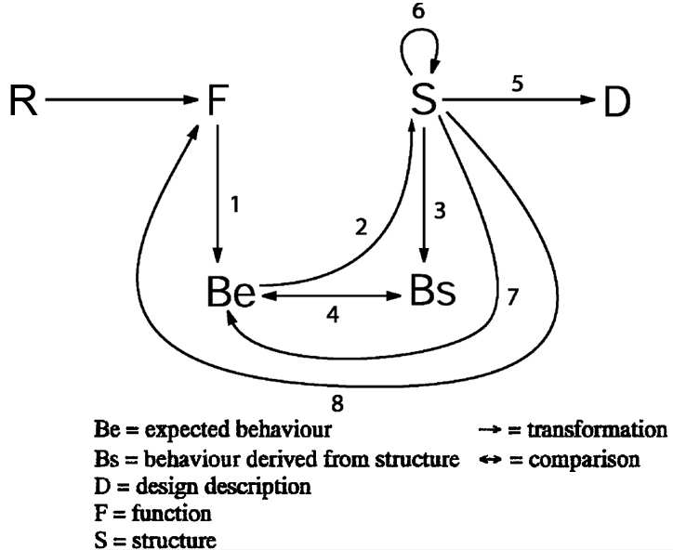
[NOTE: both function and behaviour are fundamental parts of an interactive system.]
(ISO 9241) User interface: “set of all the components of an interactive system that provide information and controls for the user to accomplish specific tasks with the interactive system.”
The user interface is a subset of the interactive system with which the user interacts.
(ISO 9241) Context of use: “combination of users, goals and tasks, resources, and environments.”
(ISO 9241) User experience: “combination of user’s perceptions and responses that result from the use and/or anticipated use of a system, product or service.”
(ISO 9241) User-system interaction: “exchange of information between a user and an interactive system via the user interface to complete the intended task.”

31-10
When is a system an AI system?
- Cognitive system (model): a system believed to implement (simulate) a form of cognition.
- Narrow AI: a system believed to perform (solve) domain specific cognitive tasks (problems)
- General AI or AGI: a system believed to perform (solve) domain-general cognitive tasks (problems: what some may also call AGI).
- Human-level AI: A system believed to realized human- level cognition (what some may also call AGI)
-> A system is an AI system when it exerts Artificial Intelligence (?)
-> Or better, when it exerts Human-like Intelligence
[NOTE: artificial: of a thing, made or constructed by human skill, especially in limitation of, or as a substitute for, something which is made or occur manually, man-made (OED)]
Negrotti, 2008: Technology of the artificial (has as its own goal, implicitly or explicitly, the reproduction of something existing in nature) vs conventional technology (traditional technology)
[In Chinese, the first ideogram for AI means “capable to work like a man”, not man made, un-natural nor fake]
🡪Difference between emulation and simulation (we would say between functional and (inner) behaviour)
AI: “the science and engineering of making intelligent machines”, based on “the conjecture that every aspect of learning or any other feature of intelligence can in principle be so precisely described that a machine can be made to simulate it.”
R.J.Sternberg: “Viewed narrowly, there seem to be almost as many definitions of intelligence as there were experts asked to define it.”
John MacCarthy, 2007: “Intelligence is the computational part of the ability to achieve goals in the world.”
Pei Wang, 2008: “The essence of intelligence is the principle of adapting to the environment while working with insufficient knowledge and resources. Accordingly, an intelligent system should rely on finite processing capacity, work in real time, open to unexpected tasks and learn form experience. This working definition interprets “intelligence” as “relative rationality”. (won the most agreed-upon definition of intelligence at a AGISI survey)
Western view vs estern view: problem solving vs adaptation to context. In the middle, we have goal achievement.
This can also be viewed as specialized intelligence vs general intelligence. It is a blend of autonomy and adaptivity.
“A system is an AI system when it automates the execution of cognitive complex tasks, that is tasks that require humans some form of intelligence to perform them.”
AI is then the capability to perform this kind of intelligence-requiring tasks. However, “complex” is a complex concept. In fact, tasks can also be parts of a task, phases, steps or so-called Detailed Work Activities (DWAs). Also, there are many types of intelligence.
Tesler’s theorem: “AI is whatever hasn’t been done yet.”
ISO definition of AI system: “engineered system that generates outputs such as content, forecasts, recommendations or decisions for a given set of human-defined objectives.AI systems are designed to operate with varying levels of automation”
ISO definition of AI: “discipline”, research and development of mechanisms and applications of AI systems.
EU AI Act definition of AI System: “machine-based system that is designed to operate with varying levels of autonomy and that can, for explicit or implicit objectives, generate outputs such as predictions, recommendations, or decisions that influence physical or virtual environments.” (this definition has undergone many modifications and might undergo further ones).
[NOTEs added to the Act:
- autonomy is only when the system is capable of modifying itself without human intervention, so we should perhaps use the term heteronomous instead, which is more applicable to “current versions” of AI (see ISO)
- influences mean even merely introducing new information to the environment.
- the systems should be based on key characteristics such as learning, reasoning or modelling capabilities
- the reference to predictions include content]
Predictive AI: it produces classifications, profiles, estimates, recommendations…
Generative AI: it produces content (textual, visual, multimedial), like ChatGPT and others.
However, these two types of AI are more less the same at a base level, in that AI generates predictions (we can see a generative AI like CHatGPT as “next word prediction” for example)
With regards to the EU AI Act, we should focus on articles 13 (transparency), 14 (human oversight, autonomy etc.) and 15 (accuracy, robustness and cybersecurity).
Article 13:
The system is designed to aid/be used by (which users) to (achieve what goal) in (which task) on (which kind of data) in (which environment) or (situation).
The system is not intended to (misuse instances) by (misusers) on (misused data).
… (ultimi 20/30 min di lezione)

7-11
AI as a Mentor: AI acts as a mentor to give students feedback to improve your work. The AI will have to provide feedback, personalizing them according to student learning levels, and considering specific learning goals, related to the assigned task.
AI as a Tutor: AI acts as a tutor whose goal is to help students by providing direct instruction and educational guidance. It can support in understanding concepts by explaining ideas and asking specific questions.
AI as a Coach: A coach is basically a friendly person guiding you, working with you, planning with you and, of course, evaluating your performance for the next match. AI acts as a coach to help students to plan and reflect on their experience during the test and team project. The coach will allow you to engage in metacognitive process, articulate your thoughts about a past event or support you in future planning by careful examination of the past and present.
AI as a Teammate: AI acts as a teammate whose goal is to help students in increasing collaborative intelligence. It can support in recognizing and balancing skill sets in team, and it can play “devil’s advocate” helping teams by careful questioning their underlying assumptions, while providing alternative perspectives for any decision. (Note: it is NOT a real teammate, so challenge its “opinions” or advice)
AI as a Student: AI can help students by checking their acquired knowledge, their understanding and fluency about a topic. Students can “teach” AI by evaluating its output and assessing what it got right or wrong. (Teaching others involves “elaborative interrogation” to empower learning, so it can support the process of teaching others to help learning.
AI as a Simulator: AI can help students to practice hard-to-practice skills in new situations. In this case, AI can build a role-playing scenario, focusing on a specific concept or series of concepts, pushing students to problem solve and make a consequential decision and giving students feedback about their performance.

21-11
AI as an agent/actor/peer vs AI as a knowledge artifact (something different, not human)
There are 70 quality dimensions for the review of an AI product.
Capacity: whether the system is relevant, concise, correct/fluent; accurate, original…
Alignment: whether the system is helpful, truthful, safe and ethical
… (TO BE COMPLETED)

23-11
Article 13 of EU AI Act
Misuse:
The misuse of a system is when it is not in the scope of the intended use. The misuse is foreseeable by a “non-paranoid” risk analyst, who evaluates habitual patterns of behaviour objectively.
It’s “reasonably foreseeable” when a judge judges so.
AI companies have to be transparent about the development of the models, with specifications for the input data, training, validation and testing data sets used. 🡪 importance about “open source” and “open data”
Main quality dimensions an AI system should have (see DSS Quality Assessment of an AI System):
- effectiveness (should be valid, reliable, robust, impactful, influent)
- efficiency
- satisfactoriness
- cybersecurity
- ethicality
EFFECTIVENESS:
General procedure proposed to get an estimate of the actual reliability of a classification model (from Cabitza et al., 2020, “The Elephant in the Machine: Proposing a new metric of Data Reliability and its Application to a Medical Case to Assess Classification Reliability”):
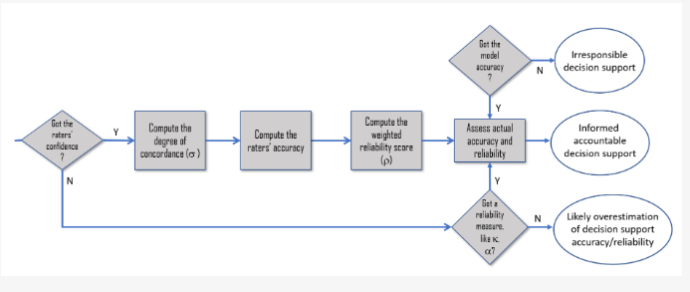
To sum up, the “elephant in the room” of Machine Learning is that we should never assume that ground truth is perfect.

(Article 13): You have to be clear about the level of accuracy, robustness and cybersecurity against which the high-risk AI has been tested and validated and which can be expected (probabilistic estimates, like confidence intervals at 95% or 90% confidence level, and specifying the reasonably foreseeable operating conditions)

Scoring Metrics:
- Accuracy for classification systems is simply the “dual” (complement w.r.t. 1) of the error. Note that accuracy is not a good proxy for robustness, reliability and utility, and does not take into account possible imbalanced classes.
- Sensitivity (recall) is the rate of true positive over true positive + false negative
- Specificity is the rate of true negative over true negative + false positive
- ROC curve is on a cartesian plane with sensitivity on the y axis and false positive rate on the x axis. However, it only estimates the probability of correctly identifying which is the positive case in a pos/neg pair. It does not consider prevalence, extrapolates unrealistic points, and not to be used to compare model (especially if curves overlap, i.e., they intersect). For example, ROC curve is not useful in clinical predictions, because you consider and want to predict single patients, not simply distinguish sick from healthy ones.
- Balanced Accuracy is the arithmetic mean of sensitivity and specificity. It considers the fact that imbalanced classes.
- F1- score is the harmonic mean of precision and recall (sensitivity)
Decision support systems are useful if the number of times they are right in detecting a health problem is greater than the number of times they are wrong. But utility (weighted average of sensitivity and specificity) also considers if:
- They are optimized to avoid the most impactful type of error (at the class level)
- They help clinicians when they need it most (i.e., the most complex/difficult/rare cases)
- They are not guessing (confidence > 75%)
- They are “calibrated” (confidence approximates to probability)

[see paper diagram for robustness]
1. Look at similarity between training set and test set (or external validation) set
2. Check whether the test set has adequate cardinality (sample size)
3. Consider discrimination, but also utility and calibration
4. Combine all up into a robustness assessment

5-12 [TO BE REVIEWED]
2 topics intertwined: what is interaction and how to design and evaluate it?
Interaction was introduced in English language in 1812, in Italian around 1950 from French. Word used in following domains: physics, chemistry, genetics, social sciences. Defined as the ‘mutual influence between individuals or groups through communication processes (verbal, gestural, etc.)’
In chinese ‘shè jiaào’ is used: it means group agency/collaborative delivery grounded on communicative processes. ‘Shè’ means family, group or society, while ‘jiaào’ means mix, intersection, friend making.

Interaction: a behavioral relation between two or more actors in which these two influence each other.

‘Meeting the universe halfway’: essay by Karen Barad about quantum physics and the entanglement of matter and meaning. She wrote this: ‘relata do not precede relations’. This means you do not have entities without the fact that these entities are related to each other, bounded.
This idea is also common in the database management framework (we find relations also in data structures)

Entities vs. actors: entities are everything that exists, while actors are particular entities acting, meaning that they have a perceivable effect on the environment.

‘Augmenting human intellect: a conceptual framework’ by Engelbart: ‘if we could see how our means of externally manipulating symbols influence both our language and our way of thinking, then we would have a valuable instrument for studying human-augmentation possibilities.

Illich: ‘we should think more about how tools affect our perception than what we can do with them, to investigate how they shape our minds and how their use shapes our perception of reality far more than we shape reality by applying or using them.’
Culkin: ‘we shape our tools and then our tools shape us’.
How has man-machine interaction changed?
Sequence of interfaces from past, present and future: the red line connecting them is the gradual reduction of the interactional friction (other example: from password to pin, to drawing, to digital fingerprint to face ID to unlock phone)
control —> familiarity —> contact —> communion —> unity
Taxonomy of agent/user interactions

Both intelligent software agents ISA and user are assumed to pursue the approximate maximisation of expected utility; the ISA’s utility also depends on the user’s action.
- 1st order effects: coercion (ex. no opt-out), deception (ex. clickbait), persuasion (control through change of attitudes and beliefs without coercion/deception, can be of 2 types, trading and nudging).
- 2nd order effects (user value function, which is the expected utility, is altered by interaction): Change U (behavioural addiction), change P (change beliefs).
Control/influence: capability to affect other agent’s behaviors and beliefs = what happens in interaction. This capability is achieved by succesfully expressing effective control/influence behaviors according to various strategies. These strategies are chosen to maximise the probability of some event to occur, that is strategies chosen at each interaction step so that the associated probability is higher than the others.
Types of control:
- physical control (coercion)
- communication control —> 1) conversational/informational influence 2) environmental influence

Kinds of interaction:
- coexistence (different objectives, no common task, no dependence): in space (synchronous) or time (asynchronous)
- synchronised (different objectives, no common task, dependence): human and system working at the same time
- cooperation (same objectives, different tasks, dependence): human and system are working each on their own resources but sharing information between them
collaboration (same objectives, common tasks, dependence): different coordination mechanisms —> shared resource (different tasks use the same resource), producer/consumer, common object (different tasks contribute to producing the same resource)
Collaboration is a particular type of cooperation.

We have feedback loops in the last 3 types.
Example of Man Machine System: humans influence the system through controls, the controls give a feedback to humans through user interfaces (originally they were just displays). These actors keep influencing each other through controls and displays.
Example of the ‘gulf model’ of interaction: user has intentions, then action specification, then the system interprets and evaluates. So we have a gulf of execution and a gulf of evaluation.

NB: it’s not just a matter of reaction!

Dubberly discussed at least 7 types of interactions along a ‘systems-theory perspective’.
1. reacting to another system (see linear system)
2. regulating a simple process
3. learning how actions affect the environment
4. balancing competing systems
5. managing automatic systems
6. entertaining (see self-regulating system)
7. conversing (see learning system)

Linear system (ex. reaction): function connecting input and output
Self-regulating system (ex. entertaining/engagement): there is a loop of measuring, comparing with goal and acting
Learning system (ex. conversation): difference from self-regulating is it is capable of setting goals, it can give itself some rules.
‘By looking beyond common notions of interactions for a more rigorous definition, we increase the possibilities open to design. And by replacing simple feedback with conversation as our primary model of interaction, we may open the world to new, richer forms of computing.’
Licklider: the hope is to achieve in some years a man-computer symbiosis, so coupling human and system tightly to create a partnership (ex. Neuralink)

[MISSING: 14/12]

[MISSING: 19/12]

[MISSING: 21/12]

